LEVEL 1 TASK
Target - https://testphp.vulnweb.com

1)recon for IP ADDRESS

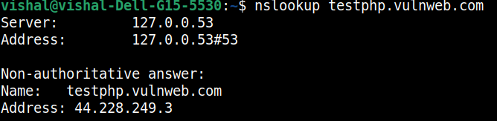
IP Address found is – 44.228.249.3(ipv4)

2)recon for DNS INFO
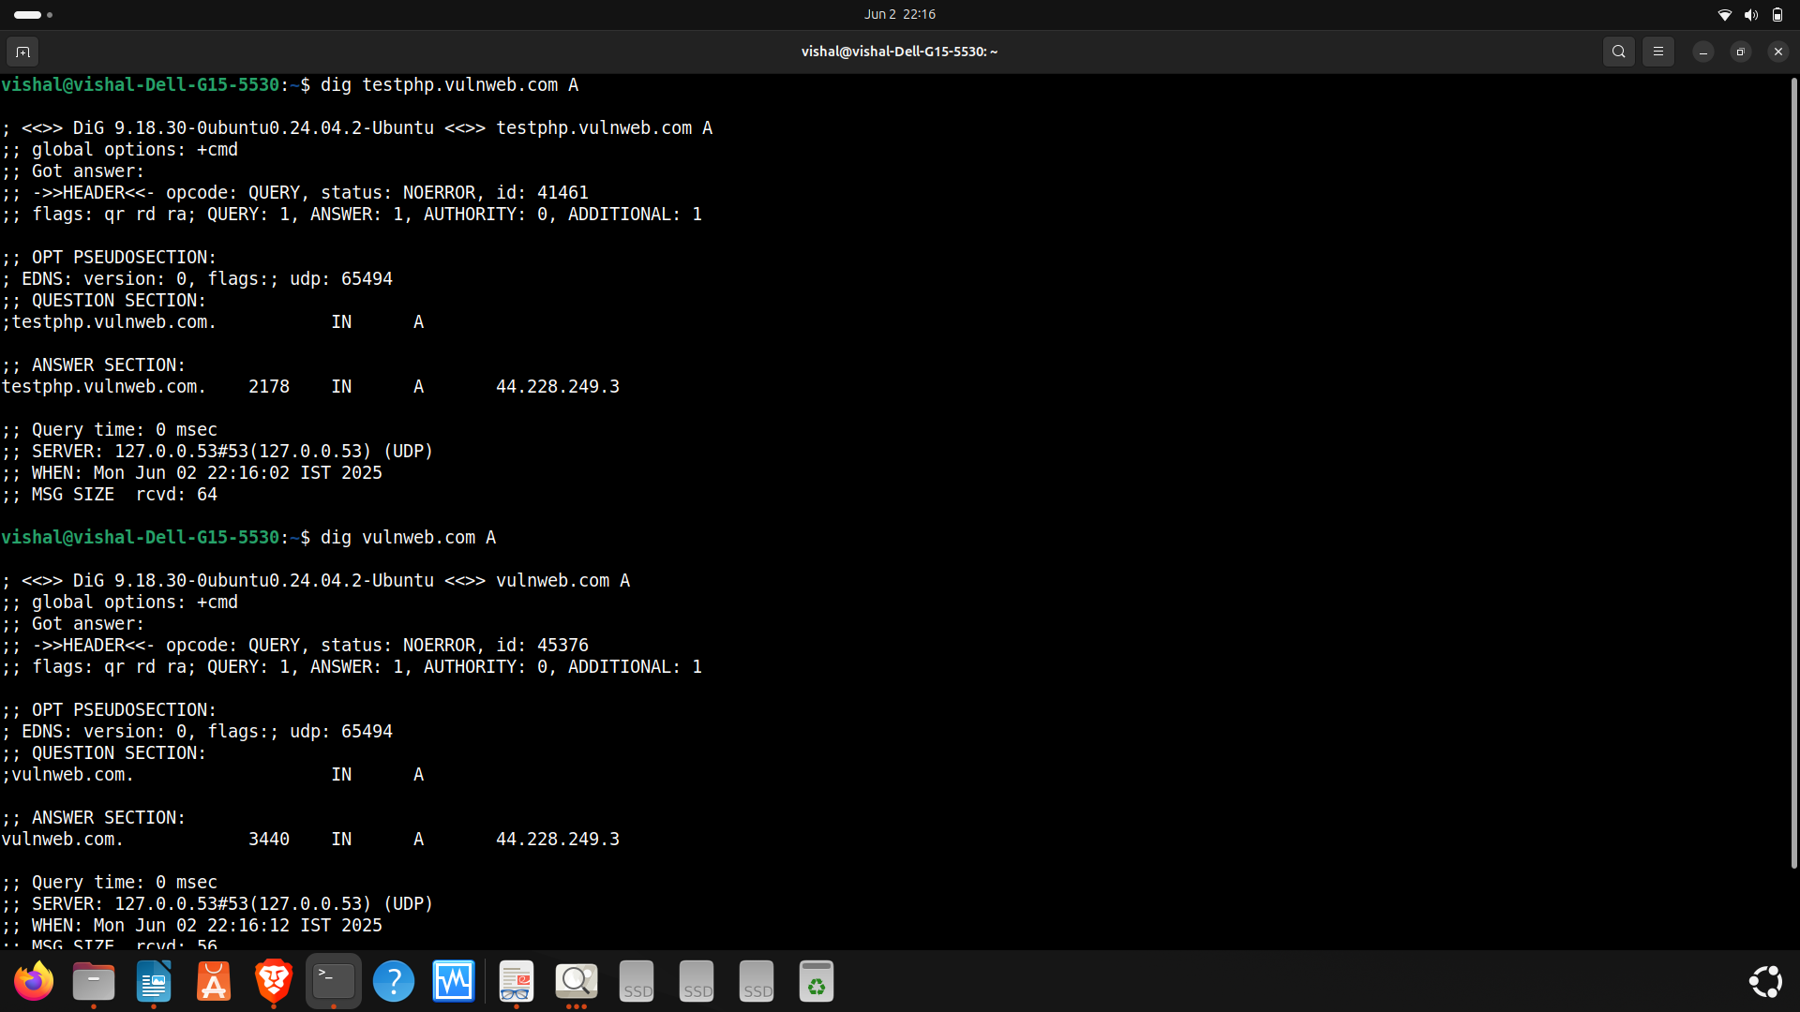
A RECORD -IPV4 ADDRESS – 44.228.249.3

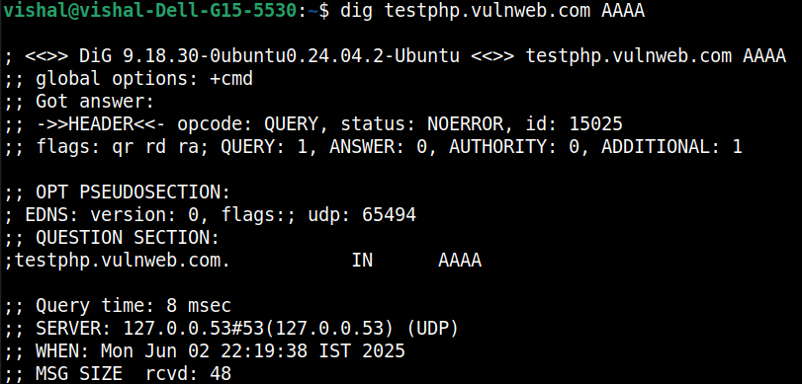
AAAA RECORD for testphp.vulnweb.com– NOT FOUND

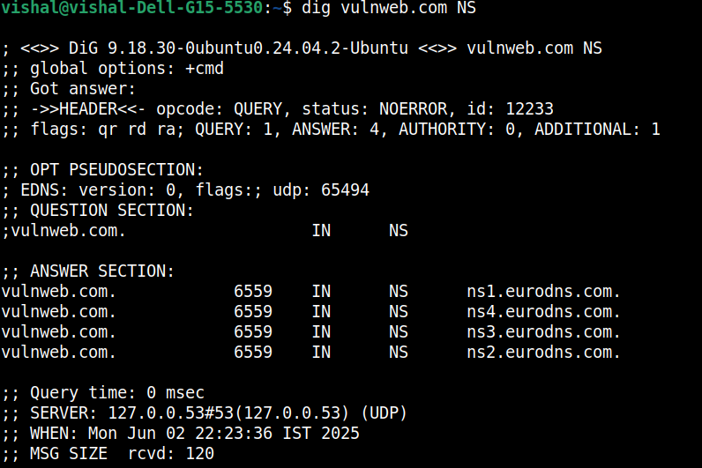
NS RECORD FOR VULNWEB.COM ARE ns1.eurodns.com , ns2.eurodns.com, ns3.eurodns.com, ns4.eurodns.com

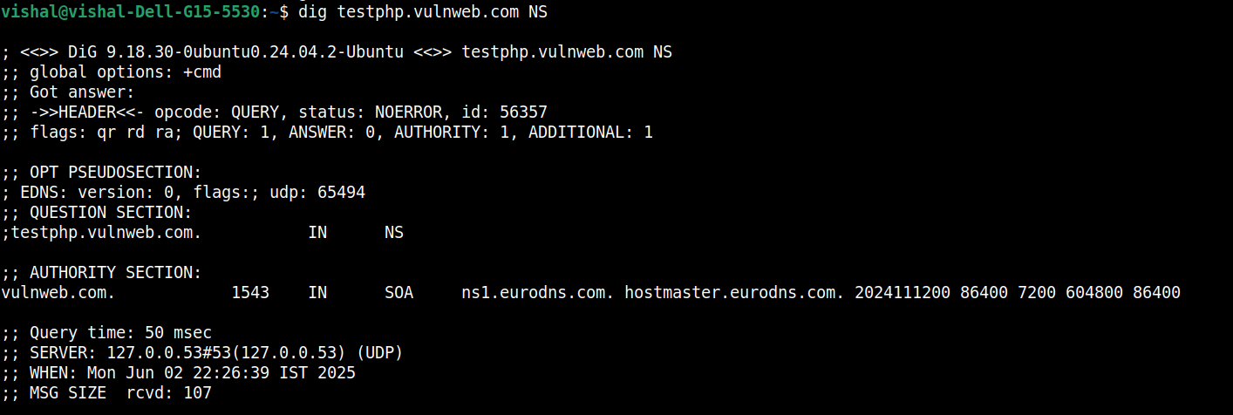
NS RECORD FOR testphp.vulnweb.com but shows parent domain (vulnweb.com) has

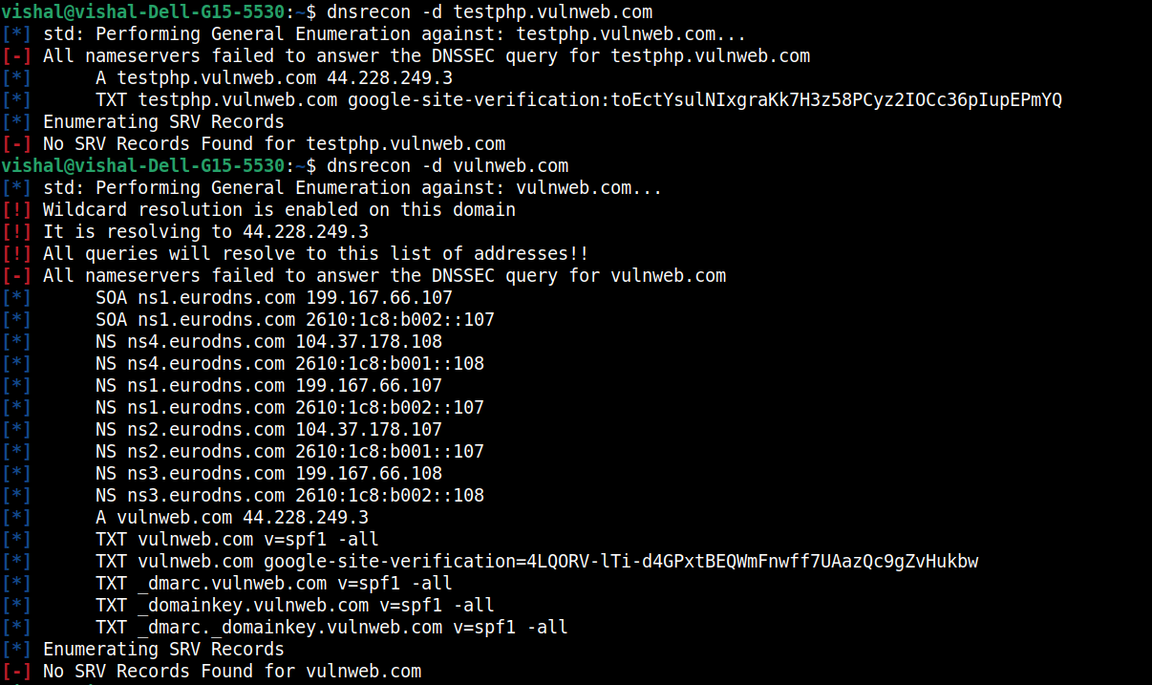
dnsrecon tool used to analyze dns records
we observe that for testphp.vulnweb.com we don’t have ns but for vulnweb.com we have

TXT RECORD FOR testphp.vulnweb.com : google-site-verification:toEctYsulNIxgraKk7H3z58PCyz2IOCc36pIupEPmYQ

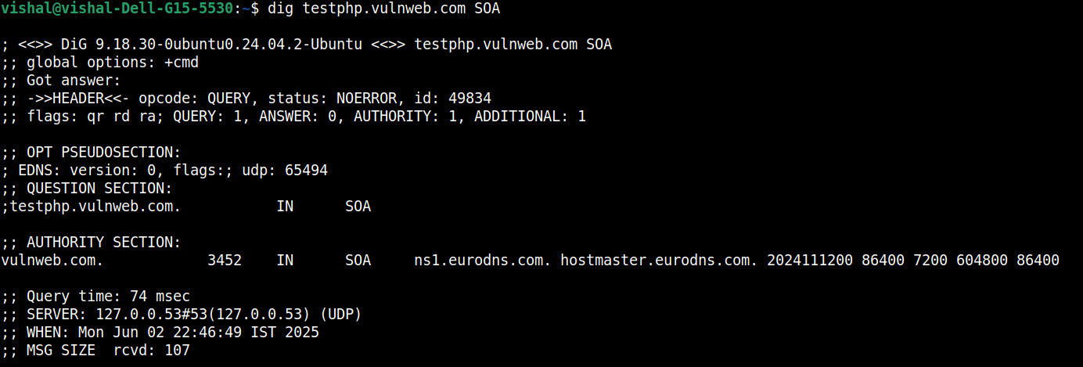
SOA RECORD : here ns1.eurodns.com appears as its the primary name server for zone and hostmaster.eurodns.com (replace first . With @ for contact email)

DNS RECORD | Testphp.vulnweb.com | Vulnweb.com
A | 44.228.249.3 | 44.228.249.3
AAAA | Not there | Not there
NS | Not there | ns1.eurodns.com ,  ns2.eurodns.com,  ns3.eurodns.com,  ns4.eurodns.com
SOA | ns1.eurodns.com.  hostmaster.eurodns.com.  2024111200 86400 7200  604800 86400 | ns1.eurodns.com. hostmaster.eurodns.com. 2024111200 86400 7200 604800 86400
TXT | google-site-verification:toEctYsulNIxgraKk7H3z58PCyz2IOCc36pIupEPmYQ | google-site-verification=4LQORV-lTi-d4GPxtBEQWmFnwff7UAazQc9gZvHukbw AND v=spf1 -all
MX | Not there | Not there
SRV | Not there | Not there

We have worked with dnsrecon tool also to be safe

3) recon for TECH STACK(cms, server etc)

USING WHATWEB -V
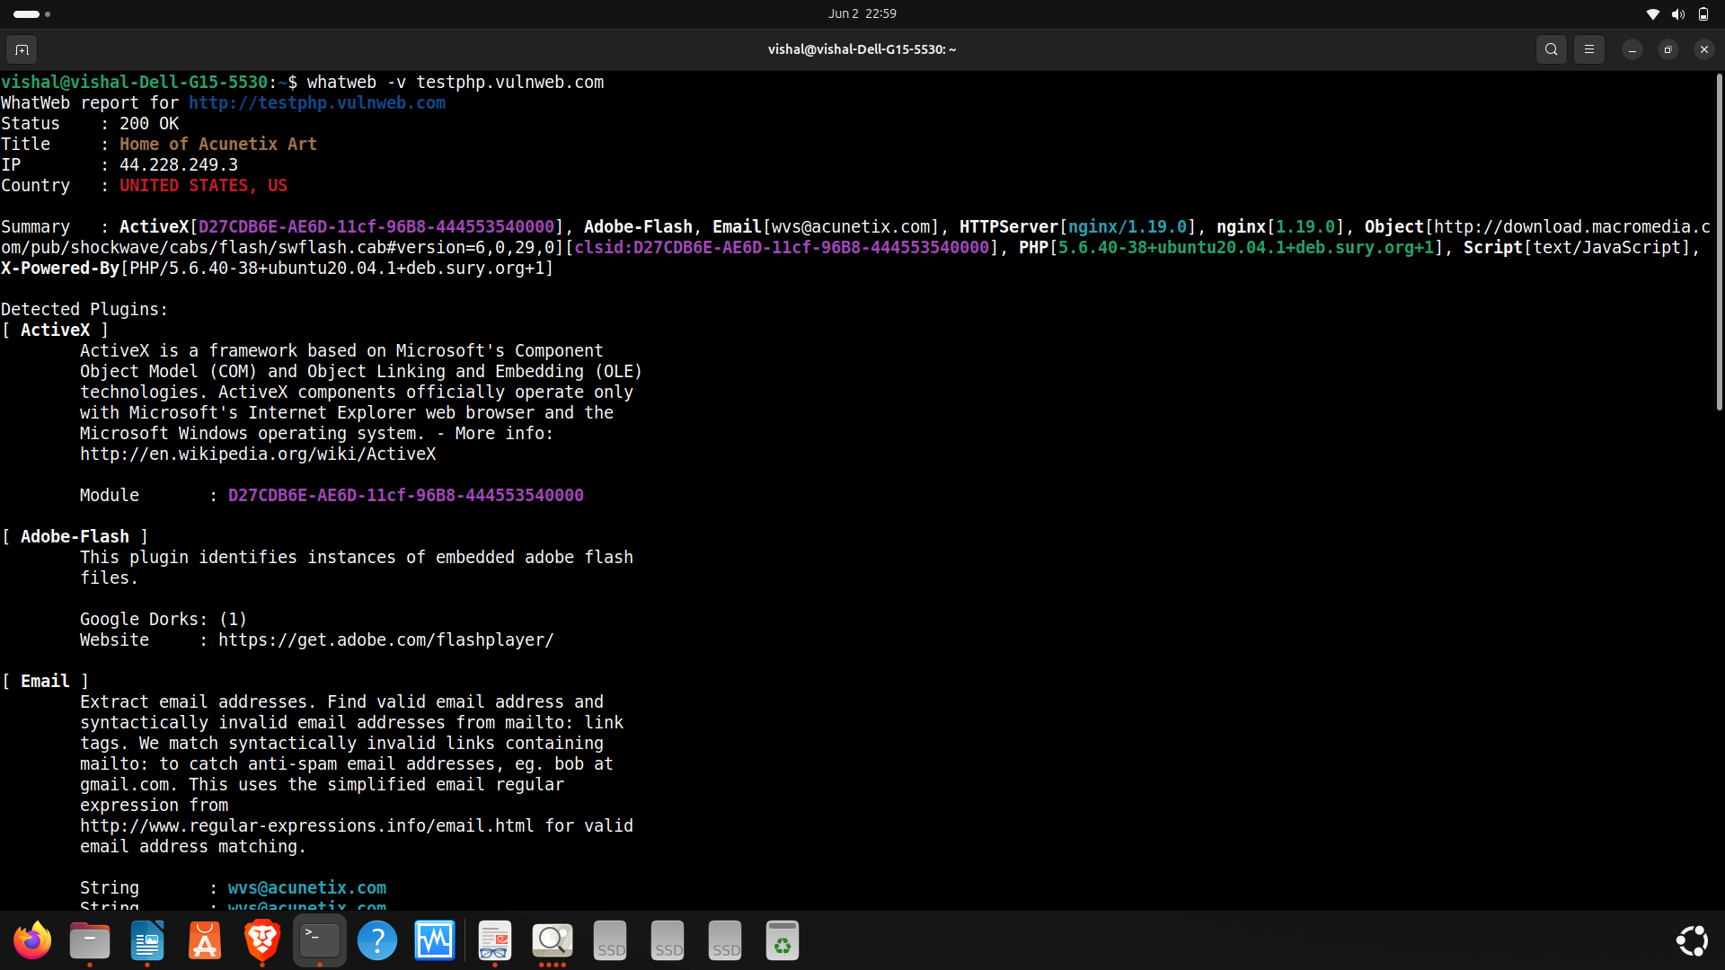
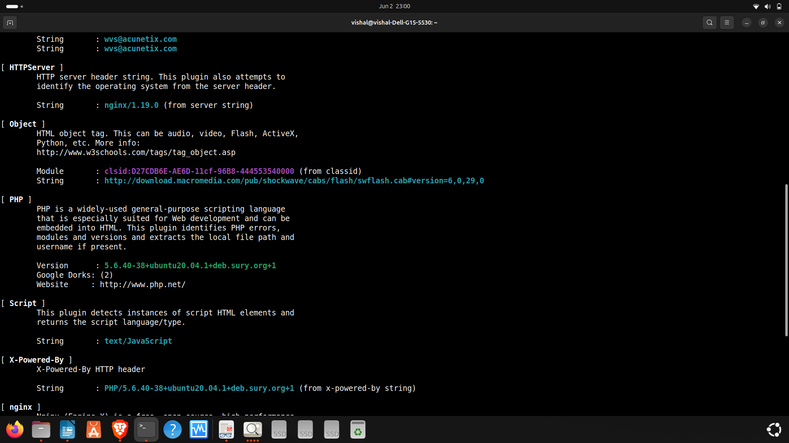

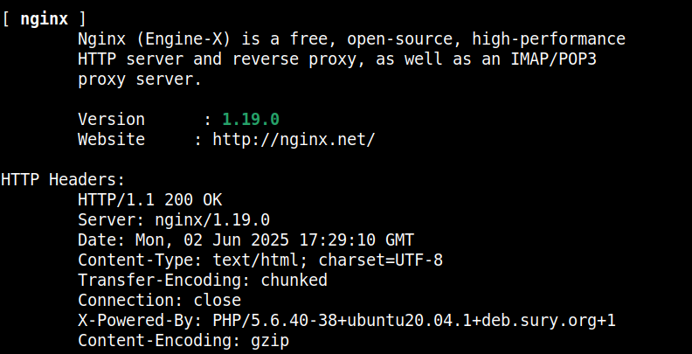
USING WAPALLYZER EXTENSION
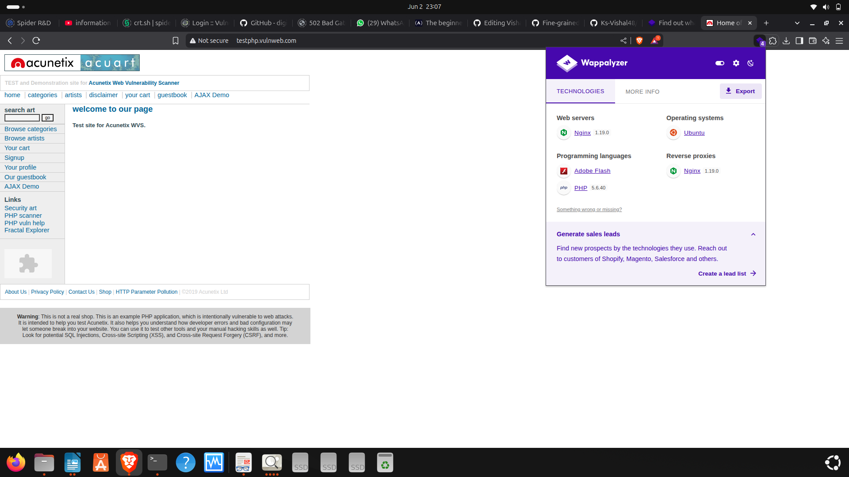
OS USED- ubuntu 20.04.01

WEB SERVERS- Nginx/1.19.0

PROGRAMMING LANGUAGES- adobe flash, javascript

REVERSE PROXIES - Nginx 1.19.0

SCRIPT: javascript

CMS: none detected

4)recon for SUBDOMAINS(IF ANY)

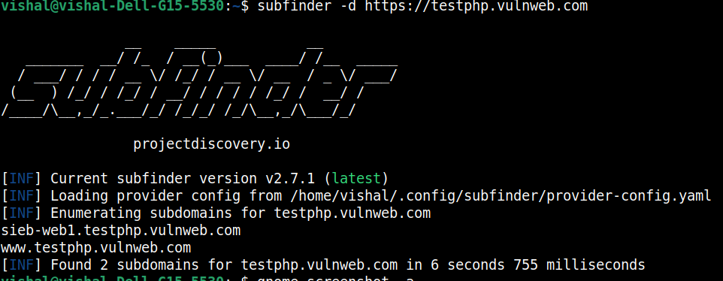
hence subdomain found using subfinder -d are

sieb-web1.testphp.vulnweb.com
www.testphp.vulnweb.com

5) recon for OPEN PORTS/SERVICES

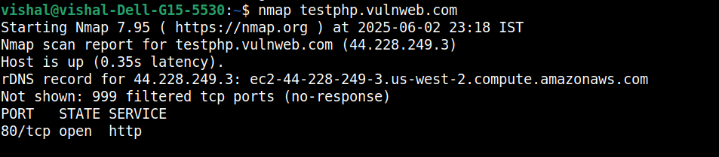
NMAP USED
port 80 is open and service is http

6)DIRECTORY STRUCTURE(Using ffuf,dirsearch)

USING FUFF we have got some directory
STATUS 200- OK
STATUS 301- permenantly moved
STATUS 403-ACCESS DENIED
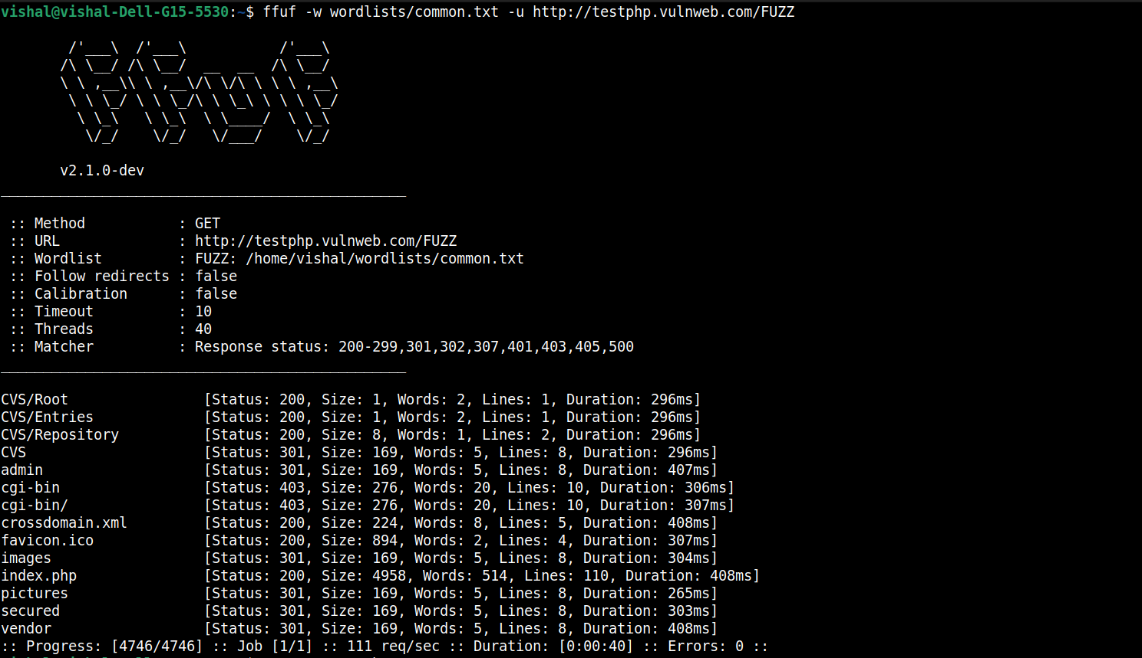

DIRSEARCH gives us more directory

here directory means like
CVS/root
testphp.vulnweb.com/CVS/Root URL exist
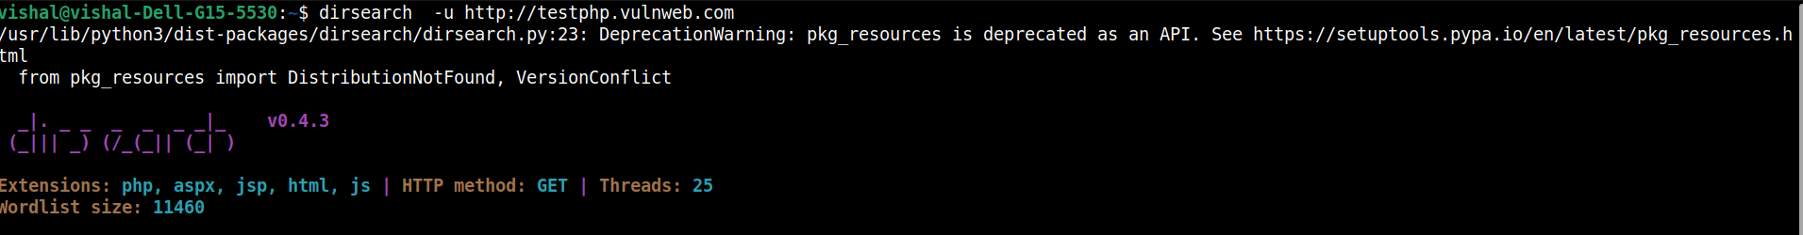

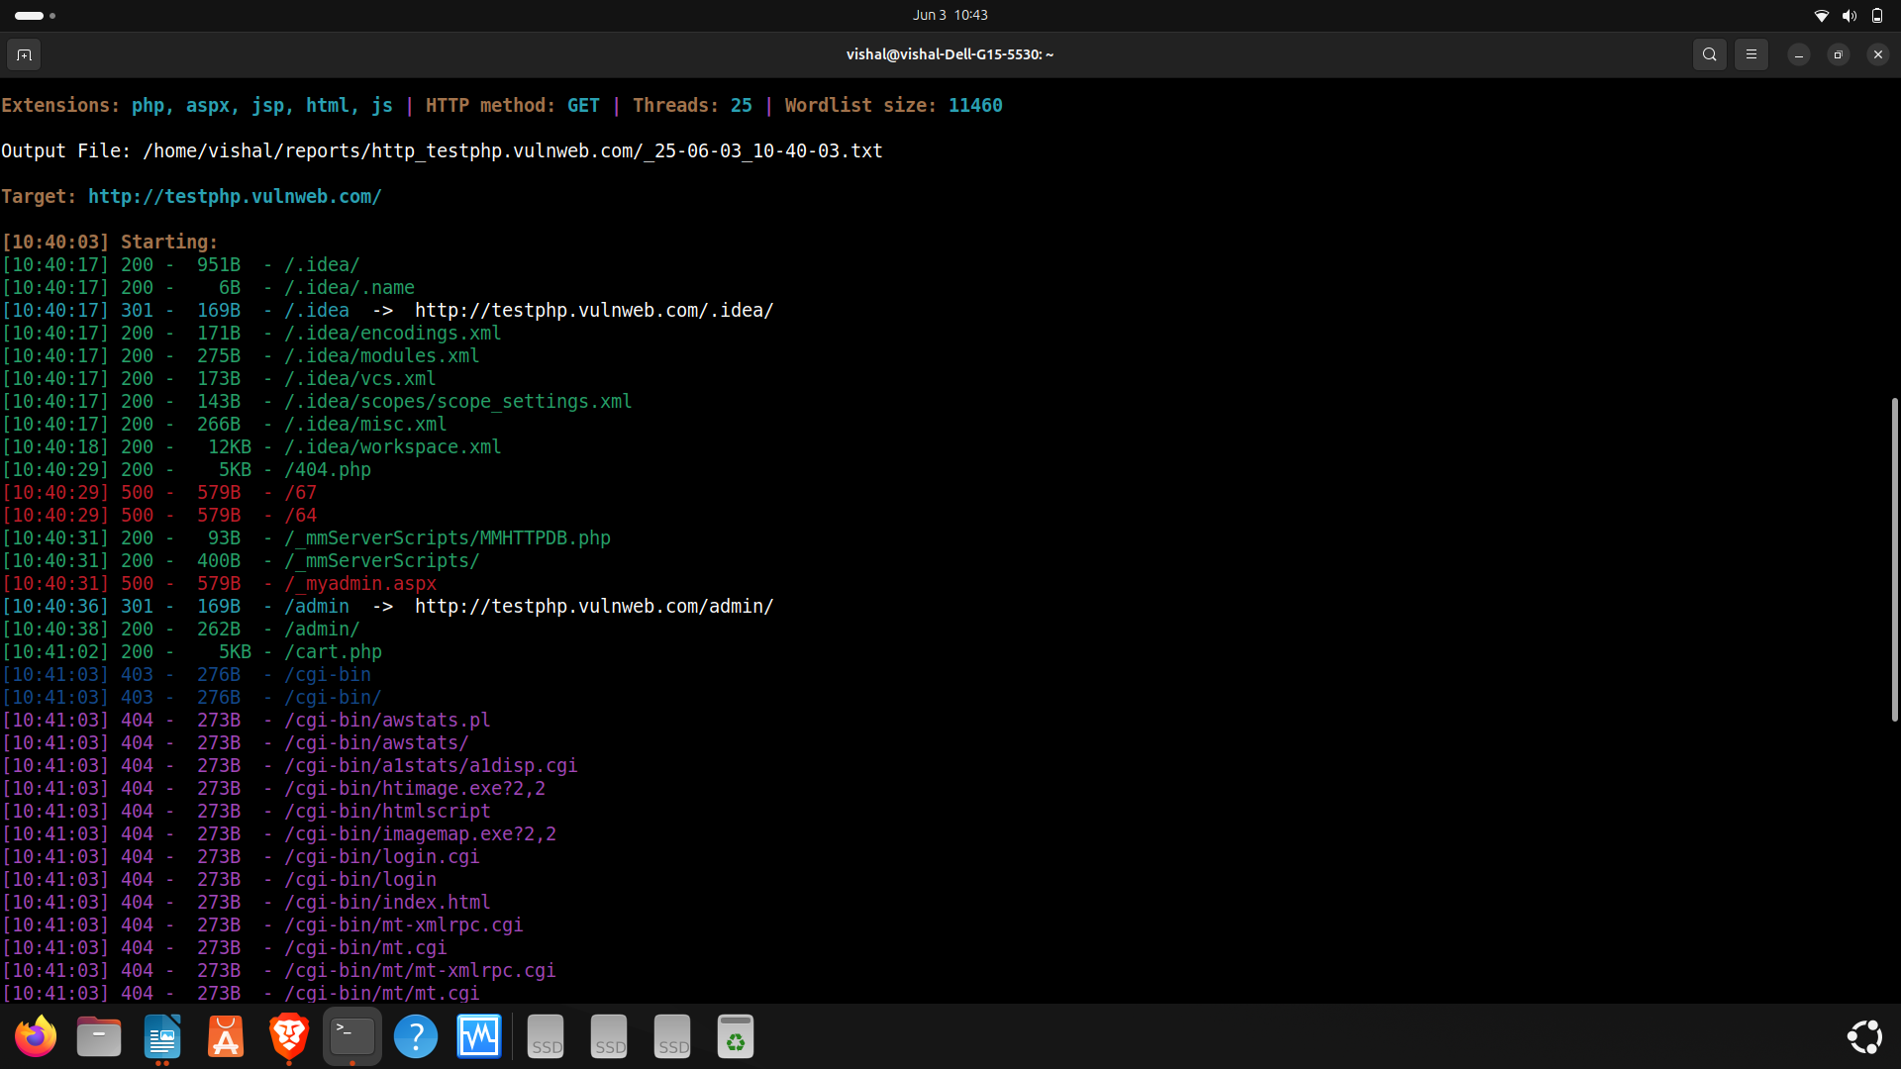

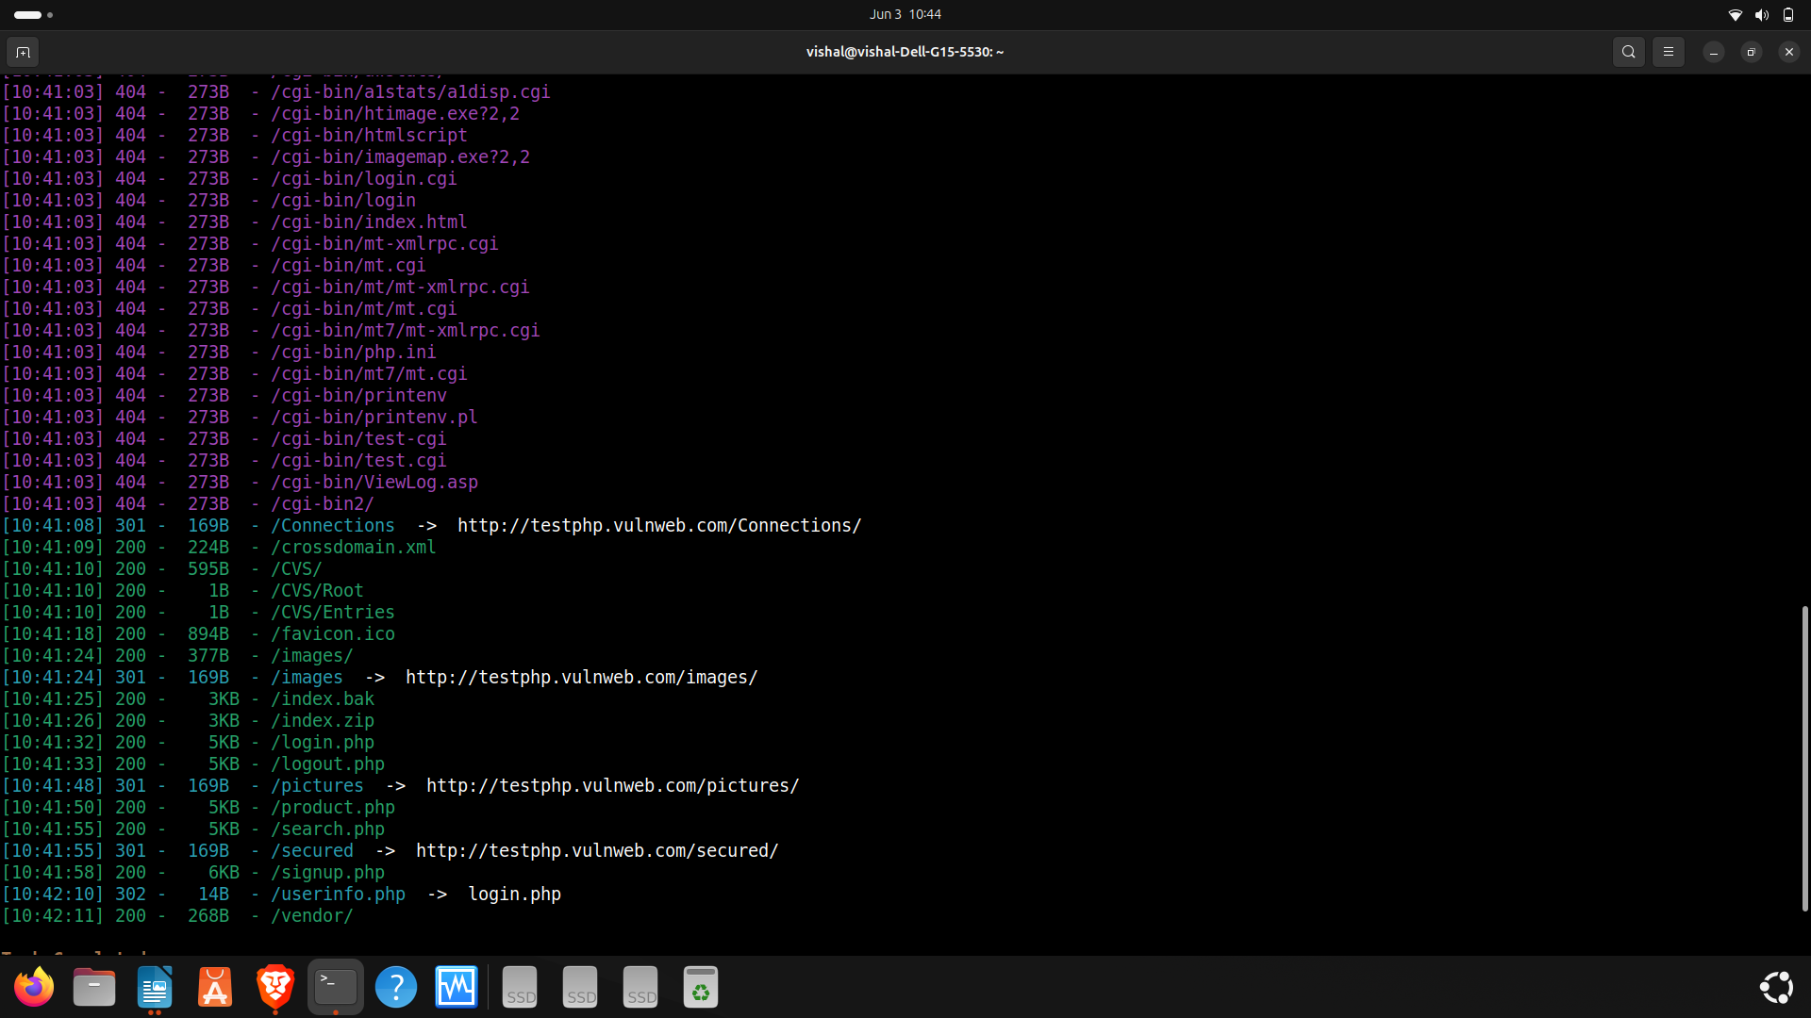
7) PAGE TITLES, PARAMETERS, FORMS

in whatweb recon we see page title
here we see title [Home of Acunetix Art]
so Home of Acutenix Art is page title

LEVEL 3
RECON ON spider-nitt.org
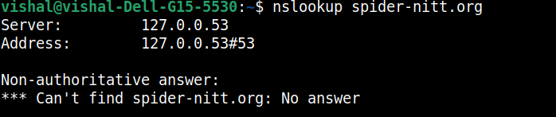
to NSLOOKUP it didn’t respond

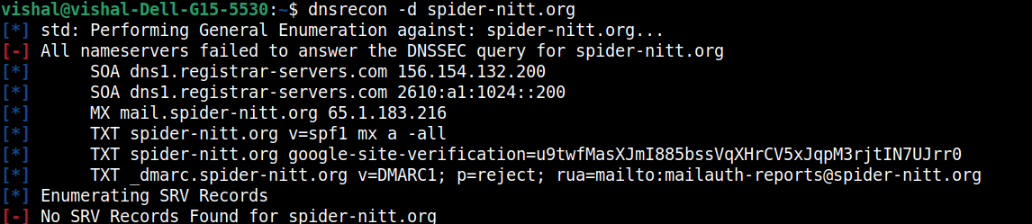

dnsrecon , ns failed to respond...its not normal

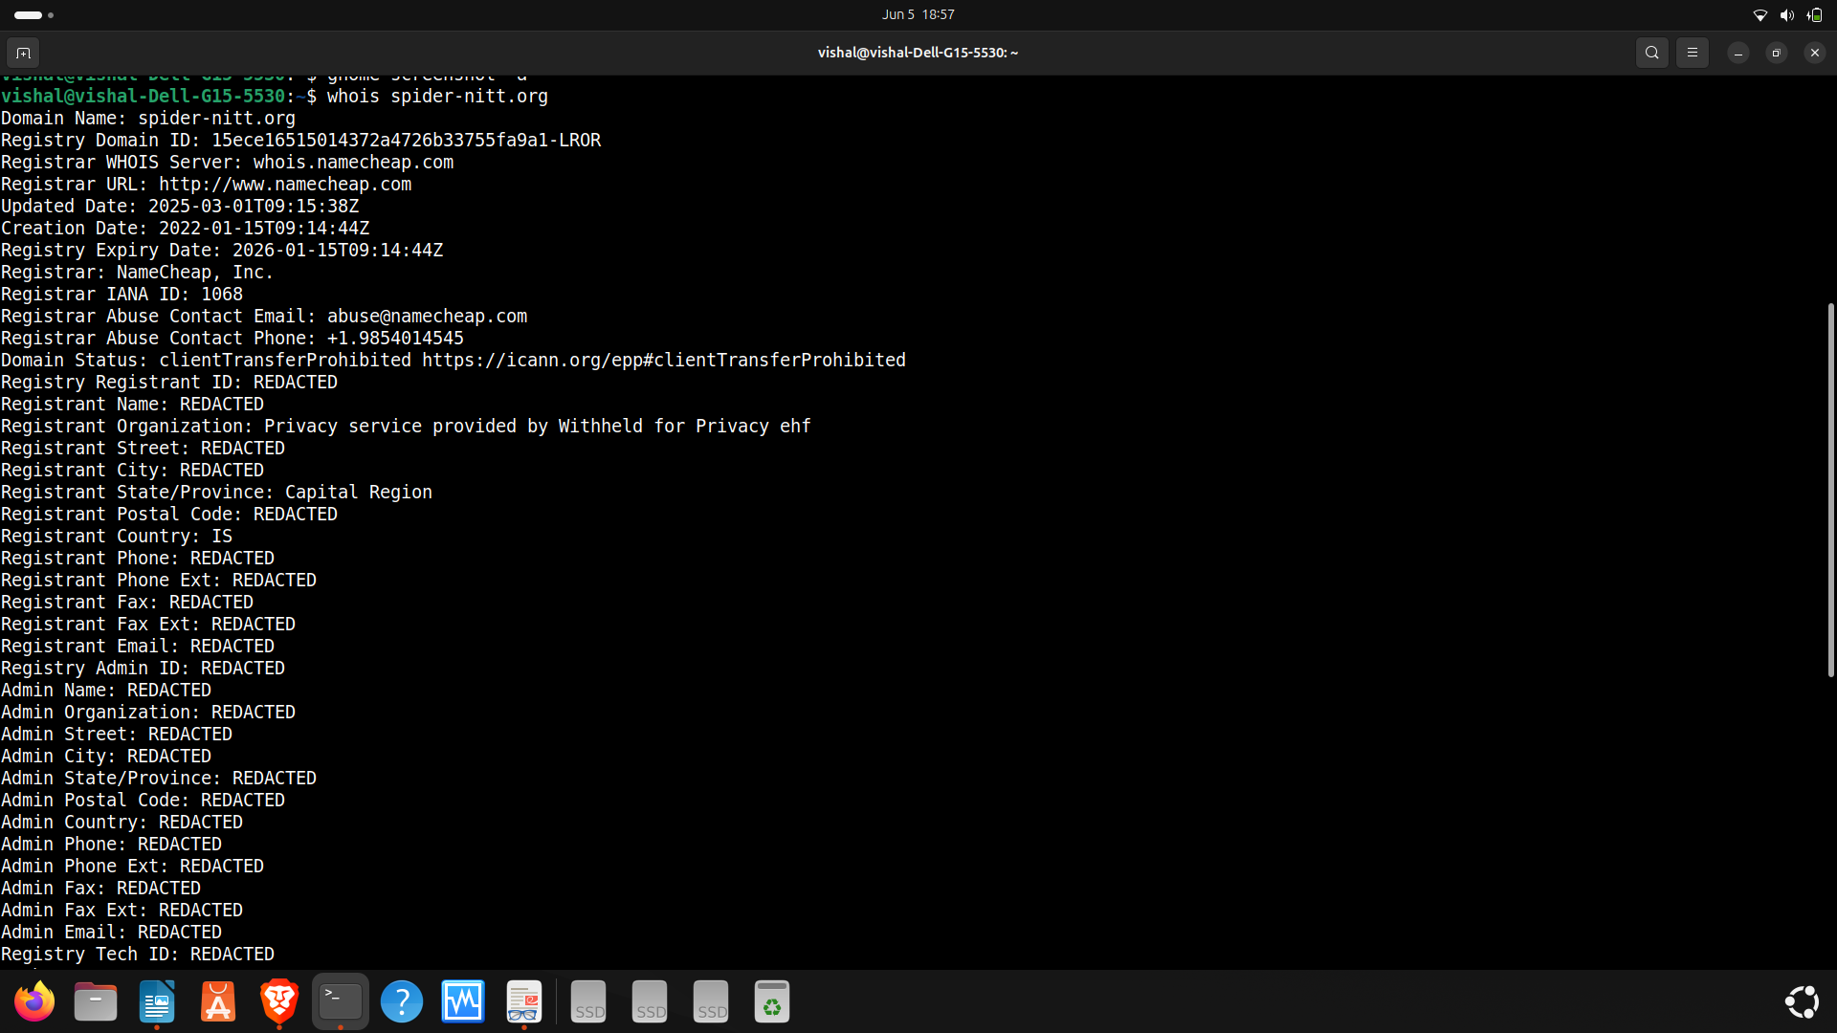
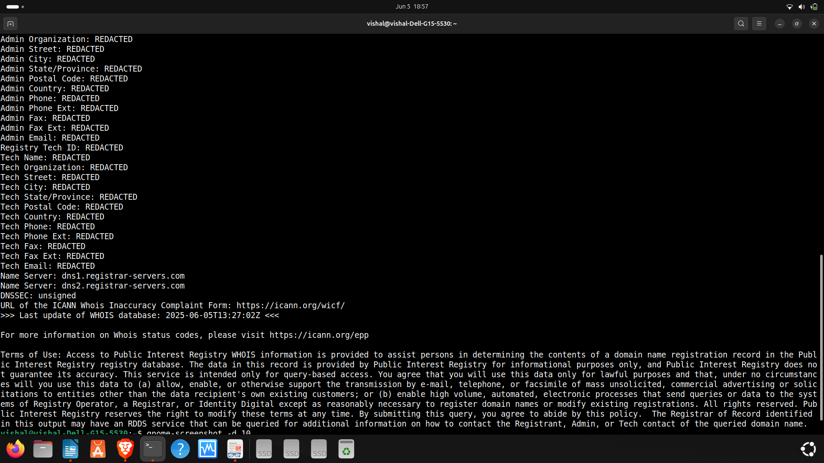
whois recon gave us ns and other info

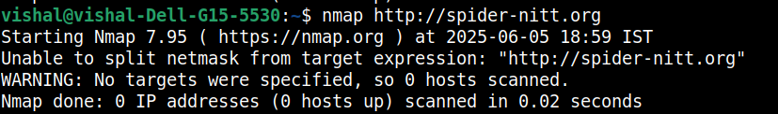
this means nmap couldn’t find site,
whatweb couldn’t access it , this means dns issue

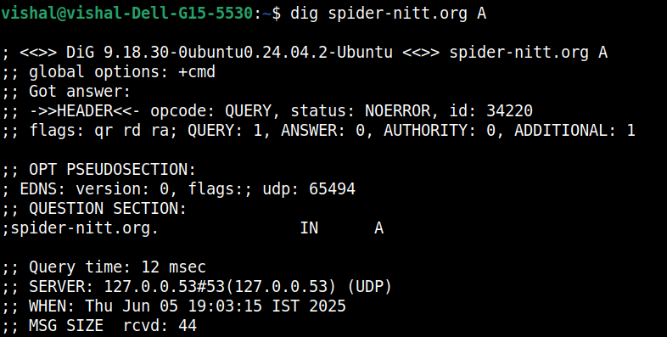
WE DONT HAVE IP address , this means this server may be down now
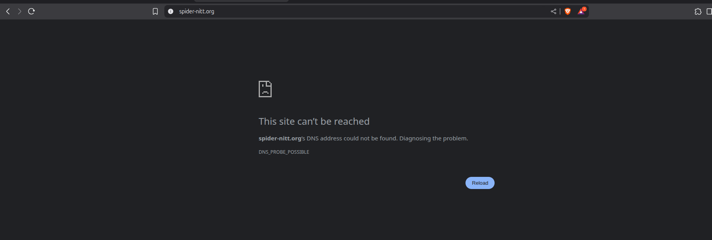
this means issue is with dns address,

NOW LETS find vulnerable subdomain and exploit it
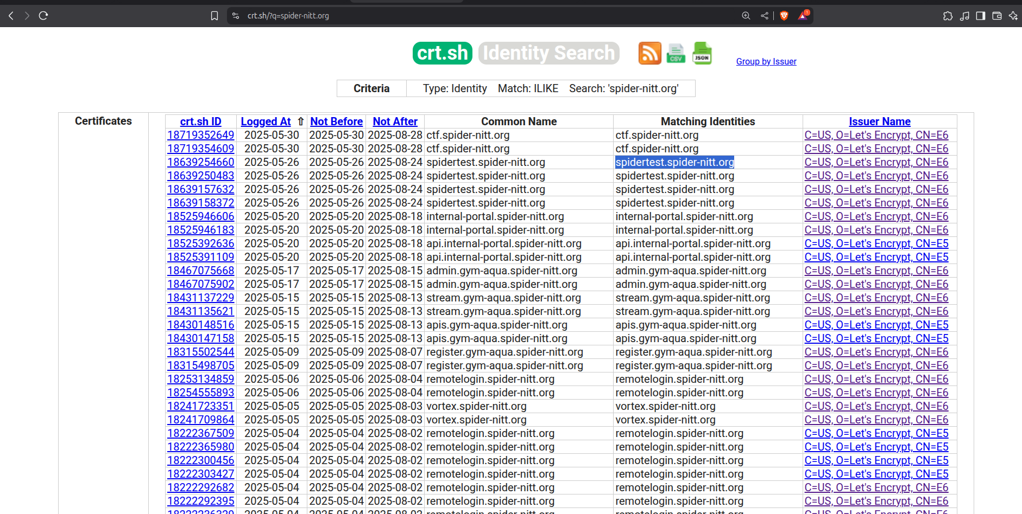
FIRST WE USED crt.sh website to find subdomains
spidertest.spider-nitt.org site was last logged at 2025-30-05 ( one day ago when it was said to work on this site)

this created fishy smell and went to site
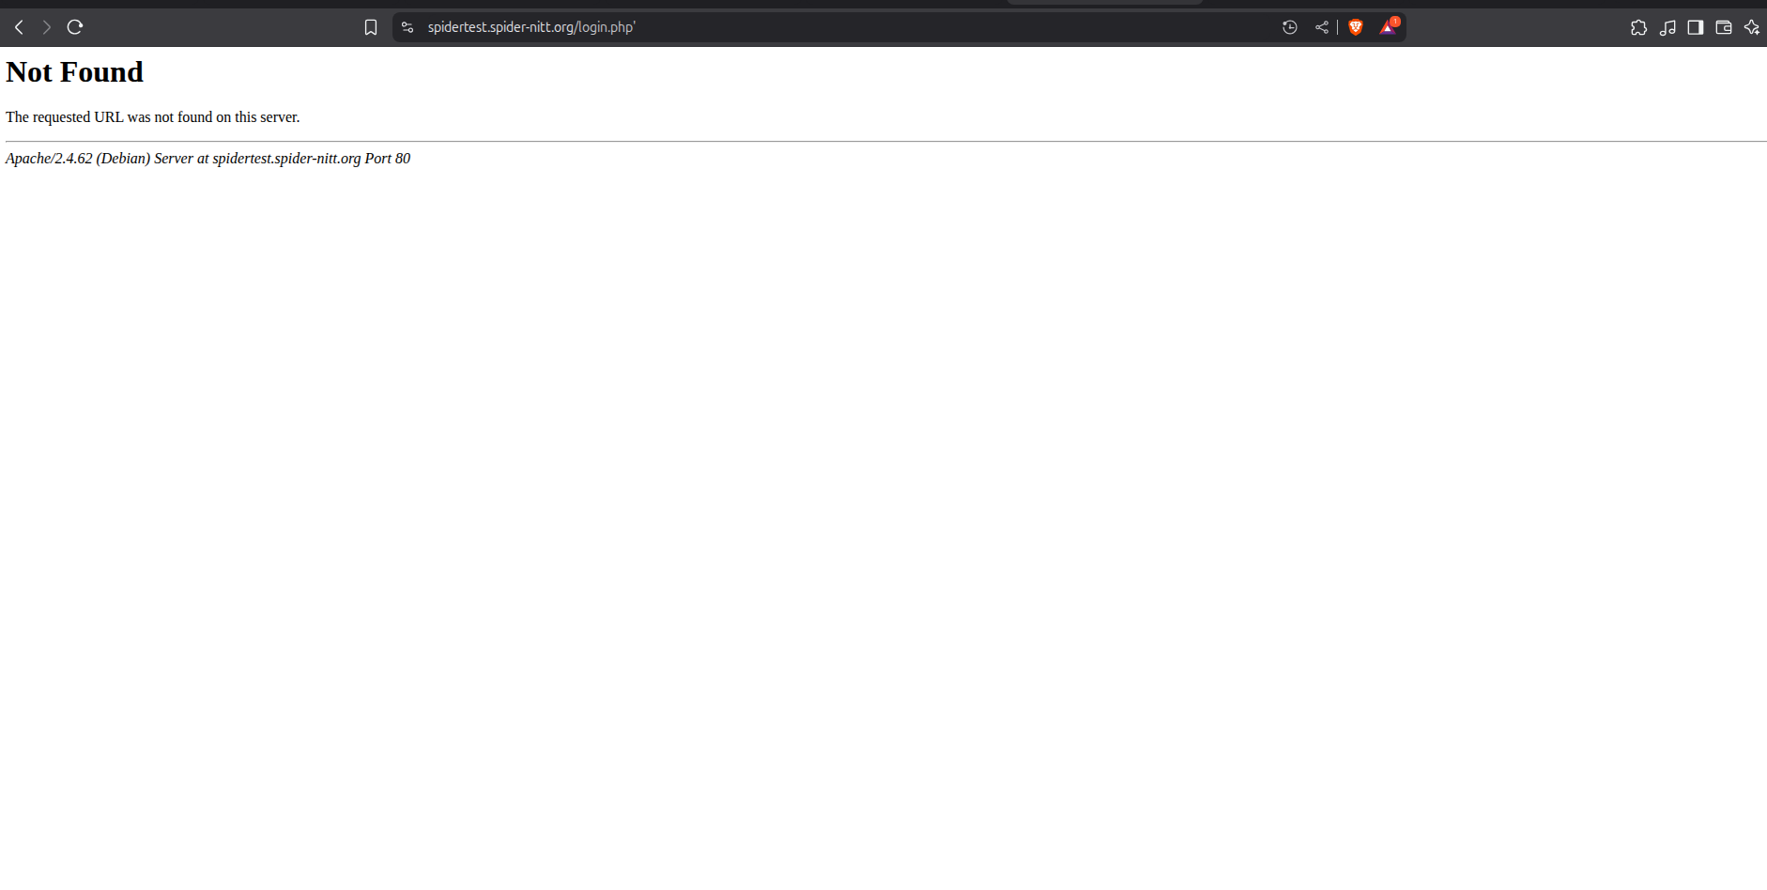
I gave ‘ in url and got this page which meant it may be safe but then
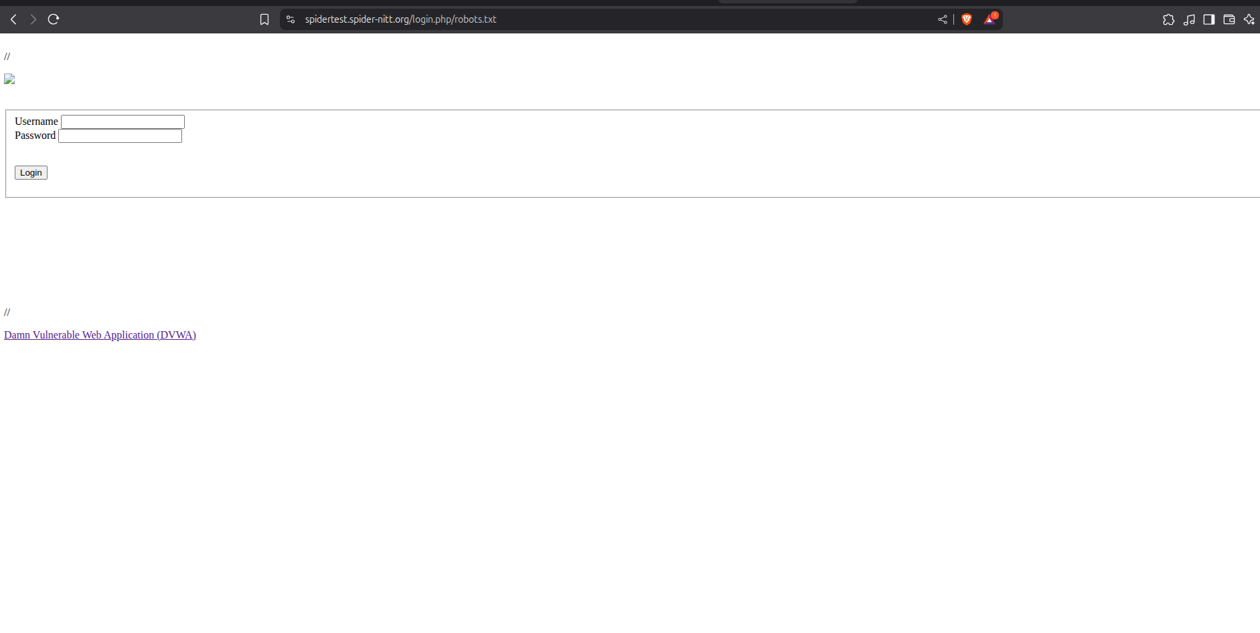
I GAVE /robots.txt and this came

I understood there is vulnerability here
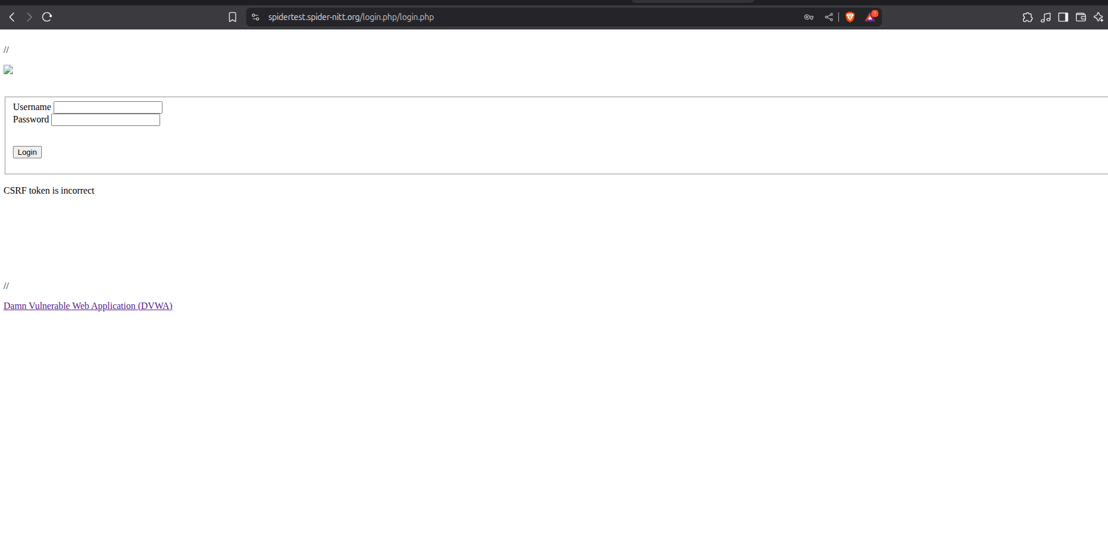
I gave admin and admin as username and password

I got “CSRF token is incorrect message”
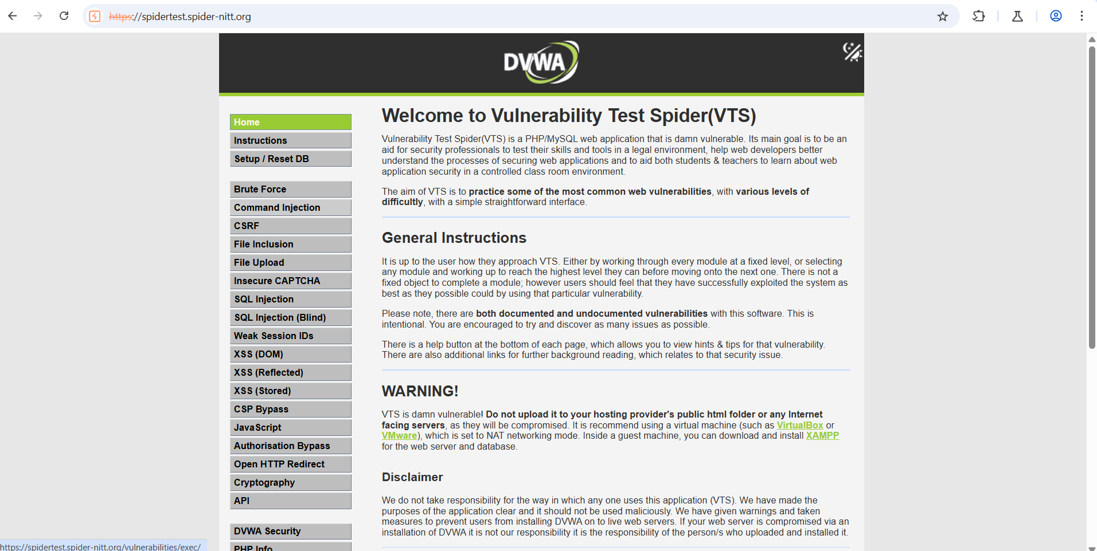

This DVWA site I need to exploit

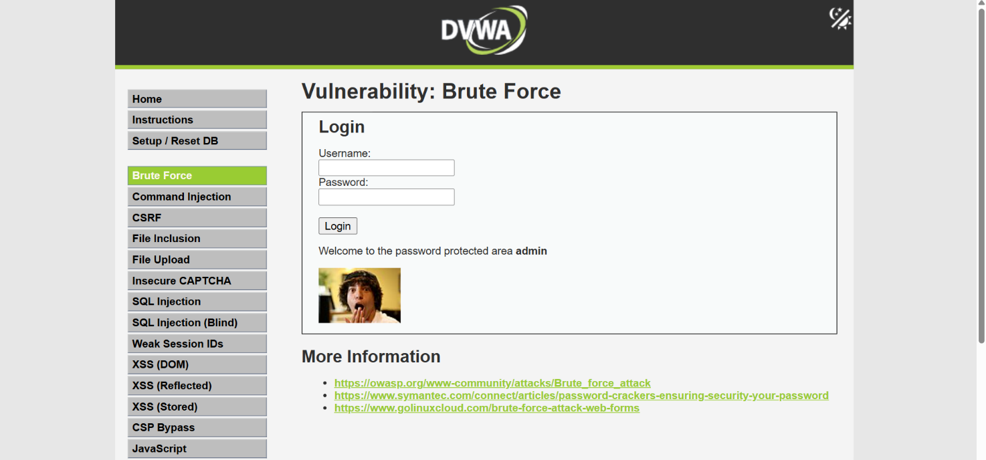
1st brute force attack

